Contact: Jeffrey H. Lapidus  Procacci Development Corporation  Phone 561 416-1400  jlapidus@procacci.us | 95 South Federal Highway  Suite 100  Boca Raton, FL 33432 | Procacci Development Corporation

Press Release

Groundbreaking of the Dual branded Hilton Garden Inn and Homewood Suites hotel to open late 2015
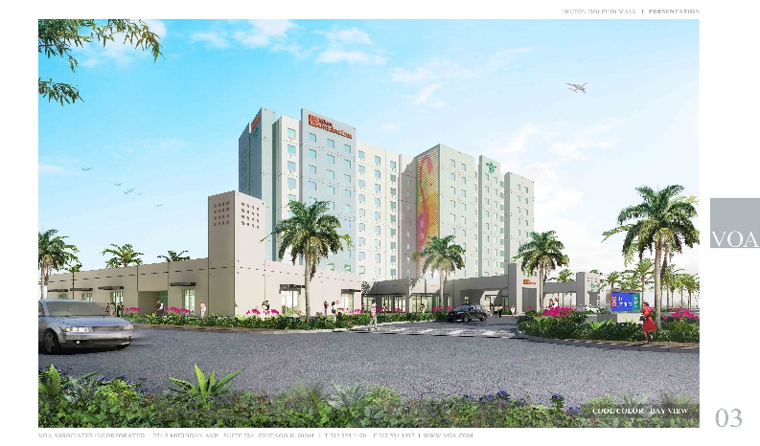
Sweetwater, Miami-Dade County, FL, November 18, 2014: Procacci Development Corporation has hired James A. Cummings, Inc. to build an iconic 11 story dual branded hotel under the Hilton Garden Inn and Hilton Homewood Suites flags adjacent to the Dolphin Mall, west of Miami International Airport. The hotels have been designed by global architectural design firm VOA Associates, Inc. and will be operated by Shaner Hotel Group, the owner and/or operator of 40 hotel properties.
“The commitment of Hilton Worldwide, Inc. to our project is a testament to the fact that the City of Sweetwater has become one of the leading cities and tourist destinations in Miami-Dade County and the State of Florida,” said Philip J. Procacci, founder and CEO of Procacci Development Corporation.
About Procacci Development Corporation
Established more than 35 years ago and headquartered in Boca Raton, FL, Procacci Development Corporation is a fully integrated real estate development, construction, management and leasing company with diverse experience, including development and construction of Class A office properties, repositioning of neighborhood shopping centers and renovating and repurposing buildings for government tenants.

